

International School

Capstone Project 1
CMU-SE 450

ARCHITECTURE DESIGN DOCUMENT
Version 1.2
Date: Sep 12, 2025

LeafSense - Coffee Leaf Disease Detection System

Created by C1SE.03
Pham Minh Trang - 28204632177
Nguyen Pham Nhat Huy - 28211100686
Nguyen Huu Thang - 28211102537
Duong Quoc Binh - 28219006390
Nguyen Huy Hoang Bao - 28219004148

Proposal Review Panel Representative:

Name Signature Date
Capstone Project 1 - Mentor:

Name MSc.Truong Dinh Huy Signature Date

PROJECT INFORMATION

Project acronym | LeafSense
Project Title | Coffee Leaf Disease Detection System
Project Mentor | MSc.Truong Dinh Huy  Email: huy.truongdinh@gmail.com  Tel: 0982132352
Team members | Name | Email | Tel
28204632177 | Pham Minh Trang | pmtrang04@gmail.com | 0911855450
28211100686 | Nguyen Pham Nhat Huy | huy785619@gmail.com | 0395546300
28211102537 | Nguyen Huu Thang | nguyenhuuthang11@dtu.edu.vn | 0702377702
28219006390 | Duong Quoc Binh | duongquocbinh@dtu.edu.vn | 0932033856
28219004148 | Nguyen Huy Hoang Bao | bao91ndu1819@gmail.com | 0385092839

DOCUMENT APPROVALS
The following signatures are required for approval of this document.
MSc.Truong Dinh Huy  Mentor | Signature | Date
Pham Minh Trang  Student ID: 28204632177  Project Leader | Signature | Date
Nguyen Pham Nhat Huy  Student ID: 28211100686  Team Member | Signature | Date
Nguyen Huu Thang  Student ID: 28211102537  Team Member | Signature | Date
Duong Quoc Binh  Student ID: 28219006390  Team Member | Signature | Date
Nguyen Huy Hoang Bao  Student ID: 28219004148  Team Member | Signature | Date

REVISION HISTORY
Version | Date | Comments | Author | Approval
1.0 | September 9, 2025 | Create Document | Duong Quoc Binh
1.1 | October 8, 2025 | Update Document | Duong Quoc Binh
1.2 | December 12, 2025 | Official Document | Duong Quoc Binh

Table of Contents
1.Introduction 6
1.1 Purpose 6
1.2 Document references 6
2. Project Statement 6
2.1. Project definition 6
2.2. Business needs/ User needs 7
2.3. Project Goal 7
3. Architecture Drivers 7
3.1 High-level requirements 7
3.2 System Overview 7
3.3 Quality Attributes 9
4.Constraints 20
4.1 Business Constraints 20
4.2 Technical Constraints 20
5.High-Level Architecture 22
5.1 Component And Connector View (C&C view) 22
5.2 Module view 24
5.3 Allocation View 25
6.References 26

1.Introduction

1.1 Purpose
The purpose of this Architecture Design Document (ADD) is to provide a clear and structured description of the software architecture for the LeafSense - Coffee Leaf Disease Detection System. This document serves as a blueprint that guides the design, development, integration, and deployment of the system, ensuring that all stakeholders share a common understanding of its objectives and structure.
Specifically, this document aims to:
Define the overall architectural vision of the LeafSense system, including its core components — Frontend (ReactJS), Backend (FastAPI), and Database (MySQL) — as well as subsystems and their interactions, as illustrated in the System Context Diagram.
Ensure that key Non-Functional Requirements (NRFs) such as performance (analysis results in ≤ 5 seconds) , accuracy (AI model ≥ 80%), usability, scalability, and security are addressed from the early stages of development.
Provide architectural guidance for the development team throughout the implementation process, especially regarding the integration of the AI model (PyTorch, Ultralytics YOLOv8) with the web application to achieve the main objective of detecting and classifying common coffee leaf diseases (rust, phoma, and leaf miner).

1.2 Document references

Table 1. Document References
No. | Reference
1 | Product Backlog Document
2 | Project Plan Document
3 | Database Design Document

2. Project Statement

Project definition
LeafSense (Coffee Leaf Disease Detection System) is an AI-powered web application designed to assist coffee farmers in detecting and managing common coffee leaf diseases. The system allows users to capture or upload images of coffee leaves, which are analyzed using a deep learning model to identify diseases such as rust, phoma, and leaf miner.
In addition to disease detection, LeafSense provides treatment recommendations, an online marketplace for purchasing agricultural products, and a community platform for sharing experiences. The system also integrates a chatbot that assists farmers by answering crop-related questions and guiding them in disease prevention and care practices.
The platform is built using ReactJS (Frontend), FastAPI (Backend), and MySQL (Database), with an AI model developed using PyTorch and Ultralytics YOLOv8, ensuring high accuracy and real-time performance in disease analysis

Business needs/ User needs
Business Needs:
Coffee is one of Vietnam’s key export crops, yet many farmers still rely on manual observation to identify diseases, leading to misdiagnosis, late detection, and inefficient pesticide use. This results in significant yield losses and reduced bean quality. Therefore, there is a strong need for a modern, intelligent system that can:
- Enable fast and accurate disease detection through AI-powered image analysis.
- Reduce pesticide misuse by providing correct treatment recommendations.
- Improve crop health monitoring and promote data-driven decision-making in farming.
- Support digital transformation in agriculture, contributing to sustainable farming and increased productivity.
User Needs:
- Farmers need an easy-to-use tool to quickly identify coffee diseases and get treatment suggestions.
- Agricultural cooperatives need a platform to monitor disease trends and support multiple farmers.
- Researchers and students need access to reliable datasets for analysis and AI model evaluation.
- Administrators need a management system for users, community content, and marketplace operations.

Project Goal
The primary goal of LeafSense is to apply Artificial Intelligence to digitize the coffee disease diagnosis process, helping farmers detect diseases early, reduce losses, and improve crop quality. The system enhances agricultural efficiency by providing intelligent tools for disease management, treatment guidance, and knowledge sharing, thereby supporting the development of smart and sustainable coffee farming in Vietnam.

3. Architecture Drivers

3.1 High-level requirements
(Refer to the Product Backlog document for Beacon)

3.2 System Overview

3.2.1 System Context

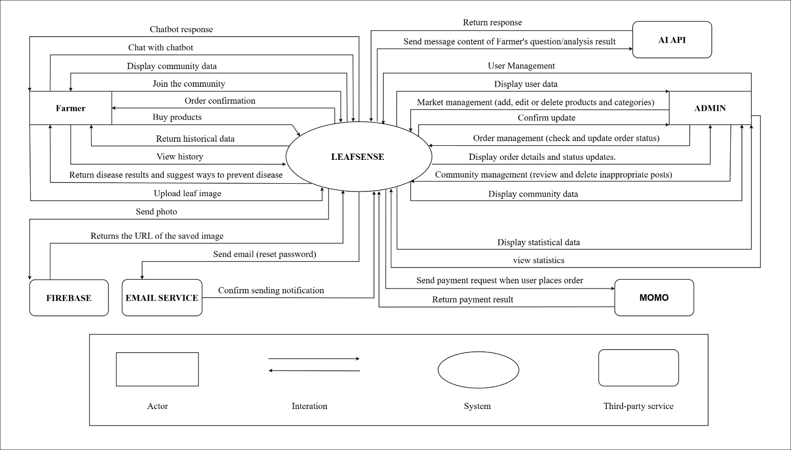

Figure 1. System context overview

3.2.2 System Context description
- Farmer:
- Authentication(login, logout)
- Capture / Upload leaf images for disease detection.
- View history and return historical data.
- Buy products from the marketplace.
- Confirm orders after purchase.
- Join the community: create posts, comment, interact (like/react).
- Display community data.
- Chat with chatbot about symptoms.
- Receive chatbot response.
- Admin:
- Authentication (login,logout).
- User management.
- Display user data.
- Market management (add, edit, or delete products and categories).
- Order management (check and update order status).
- Display order details and status updates.
- Community management (review and delete inappropriate posts).
- Display community data.
- AI:
- Receive message content of Farmer’s question or analysis result from LeafSense.
- Process and return the response back to the system.
- Firebase:
- Receive uploaded images from LeafSense.
- Return the URL of the image.
- Email Service:
- Send email to reset password.
- Confirm sending notification back to LeafSense.
- Payment:
- Receive payment request from LeafSense when user places order.
- Return payment result to the system.

3.3 Quality Attributes

3.3.1. Use Case Entities

Table 2. Use Case Entity: Farmer (E01)
ID | E01
Title | Farmer / Cooperative
Description | End-user who captures or uploads coffee leaf images, views AI detection results, and receives treatment recommendations.
Provides  Assumptions | Provides leaf images and farm-related information for disease analysis.
Requires  Assumptions | Requires login credentials and stable internet to access the system.
Identified Use Cases | UC01 Register, UC02 Login, UC03 Upload Image, UC04 Detect Disease, UC05 View Result, UC06 Treatment Recommendation, UC07 Chatbot Support, UC08 View History

Table 3. Use Case Entity: Administrator (E02)
ID | E02
Title | Administrator
Description | Manages the LeafSense system including user accounts, dataset, posts, and AI model performance.
Provides  Assumptions | Provides access control, system configuration, and moderation.
Requires  Assumptions | Requires admin credentials and backend access privileges.
Identified Use Cases | UC09 Manage Users, UC10 Manage Dataset, UC11 Approve Content, UC12 Monitor Dashboard, UC13 Retrain AI Model

Table 4. Use Case Entity: Researcher / Tester (E03)
ID | E03
Title | Researcher / Tester
Description | Evaluates AI model accuracy, exports reports, and provides feedback for performance improvement.
Provides  Assumptions | Provides test data and analysis feedback.
Requires  Assumptions | Requires access to AI performance dashboard and report generation module.
Identified Use Cases | UC14 Evaluate AI Model, UC15 Export Report, UC16 Provide Feedback

Table 5. Use Case Entity: Community User (E04)
ID | E04
Title | Community User
Description | Participates in the community by viewing, posting, commenting, and reacting to content.
Provides  Assumptions | Provides user-generated content (posts/comments)..
Requires  Assumptions | Requires a registered account and community access privileges.
Identified Use Cases | UC17 View Posts, UC18 Post Content, UC19 Comment & React.

3.3.2. Operational Use Case

Table 6. Operational Use Case: Register New Account (UC01)
ID | UC01
Title | Register New Account
Description | A new user (farmer or cooperative) registers an account to access the system’s features such as AI-based coffee leaf disease detection, community interaction, and treatment recommendations.
Entities  Involved | E01
Preconditions | The user has internet access and opens the LeafSense web application.  The user is not currently logged in and has no existing account.
Primary Flow | 1. The user navigates to the “Register” page from the homepage or login screen.  2. The system displays the registration form.  3. The user enters required details: full name, email address, password, and phone number.  4. The user optionally agrees to terms of service and privacy policy.  5. The user clicks “Register”.  6. The system validates all input fields (format, password complexity, and unique email).  7. The system stores the user’s information securely in the database.  8. The system sends a verification email to confirm the registered email address.  9. After verification, the system activates the account and redirects the user to the login page.
Post  Conditions | A new user account is successfully created and marked as “active” after verification.  - The user can now log in to access system features.
Alternate  Flows | A1: If the entered email already exists → The system displays “This email is already registered.”  A2: If the password doesn’t meet the security policy → Show “Password must contain at least 8 characters, one uppercase, one number.”  A3: If the verification email fails to send → System displays “Registration successful, but email verification pending.”  A4: If input validation fails (empty fields, wrong format) → Highlight invalid fields and prompt correction.

Table 7. Operational Use Case: Login (UC02)
ID | UC02
Title | Login
Description | A registered user logs into the system to access personal features such as uploading images and viewing history.
Entities  Involved | E01
Preconditions | The user already has a valid registered account.
Primary Flow | 1. User navigates to the login page.  2. Enter email and password.  3. Click Login.  4. System verifies credentials.  5. If valid, user is redirected to the dashboard or homepage.
Post  Conditions | User session is created and stored; user gains access to personal functions.
Alternate  Flows | Invalid credentials → Display error message.  Forgotten password → User clicks “Forgot Password” and receives reset email.

Table 8. Operational Use Case: Upload Coffee Leaf Image (UC03)
ID | UC03
Title | Upload Coffee Leaf Image
Description | A user captures or uploads an image of a coffee leaf for disease detection.
Entities  Involved | E01
Preconditions | The user is logged in.
Primary Flow | 1. Navigate to “Upload Image” page.  2. Choose an image from device or take a photo.  3. Click “Analyze.”  4. System sends the image to the AI service.  5. AI model analyzes and returns disease classification.
Post  Conditions | The image and analysis result are stored in the user’s history.
Alternate  Flows | Image upload fails due to poor connection → Display retry option.  Image format invalid → Show error message.

Table 9. Operational Use Case: View Disease Detection Result (UC04)
ID | UC04
Title | Receive Treatment Recommendation
Description | The system provides disease-specific treatment and preventive advice based on AI diagnosis.
Entities  Involved | E01
Preconditions | Disease detection (UC04) completed successfully.
Primary Flow | 1. System retrieves disease result.  2. Display treatment advice (e.g., pesticide, soil care, irrigation tips).  3. User may view related marketplace items for treatment.
Post  Conditions | Recommendations displayed to the user and optionally stored for future reference.
Alternate  Flows | No matching recommendation found → System displays “Consult expert” message.

Table 10. Operational Use Case: Receive Treatment Recommendation (UC05)
ID | UC05
Title | Receive Treatment Recommendation
Description | The system provides disease-specific treatment and preventive advice based on AI diagnosis.
Entities  Involved | E01
Preconditions | Disease detection (UC04) completed successfully.
Primary Flow | 1. System retrieves disease result.  2. Display treatment advice (e.g., pesticide, soil care, irrigation tips).  3. User may view related marketplace items for treatment.
Post  Conditions | Recommendations displayed to the user and optionally stored for future reference.
Alternate  Flows | No matching recommendation found → System displays “Consult expert” message.

Table 11. Operational Use Case: Manage Community Posts (UC06)
ID | UC06
Title | Manage Community Posts
Description | A community user or admin interacts with community content through posts, comments, or moderation.
Entities  Involved | E01, E04, E02
Preconditions | User is logged in and has community access.
Primary Flow | 1. User navigates to “Community.”  2. View posts, comment, or react.  3. Admin monitors and approves content.
Post  Conditions | New posts/comments saved; approved posts visible to all users.
Alternate  Flows | Post flagged as inappropriate → hidden or deleted by admin.

Table 12. Operational Use Case: Manage User Accounts (UC07)
ID | UC07
Title | Manage User Accounts
Description | Administrator manages all user profiles and permissions in the system.
Entities  Involved | E01
Preconditions | Admin logged in with valid credentials.
Primary Flow | 1. Navigate to “Admin Dashboard.”  2. View list of users.  3. Create, edit, or delete user accounts as necessary.
Post  Conditions | Updated user data stored in the database.
Alternate  Flows | Unauthorized user tries to access → Access denied.

Table 13. Operational Use Case: Evaluate AI Model (UC08)
ID | UC08
Title | Evaluate AI Model
Description | A researcher reviews AI performance and generates analysis reports.
Entities  Involved | E03
Preconditions | Researcher logged in with granted access rights.
Primary Flow | 1. Access AI performance dashboard.  2. View metrics (Confusion Matrix, Accuracy, F1-score).  3. Export report in Excel or PDF format.
Post  Conditions | Report exported successfully.
Alternate  Flows | System error or missing data → Display “Data unavailable.”

Table 14. Operational Use Case: Monitor AI Model and Retrain (UC09)
ID | UC09
Title | Monitor and Retrain AI Model
Description | Administrator oversees AI performance and retrains model when accuracy declines.
Entities  Involved | E02
Preconditions | Admin logged in and has access to model management module.
Primary Flow | 1. Open “AI Management.”  2. Review model accuracy metrics.  3. If needed, upload new dataset and trigger retraining.
Post  Conditions | Updated model deployed; performance metrics refreshed.
Alternate  Flows | Insufficient data → Retraining aborted, notification sent to admin.

Table 15. Operational Use Case: Chatbot Assistance (UC10)
ID | UC10
Title | Chatbot Assistance
Description | A user interacts with the AI chatbot to receive information or quick guidance.
Entities  Involved | E01
Preconditions | User is logged in and has internet connection.
Primary Flow | 1. User opens Chatbot.  2. Enters question (e.g., “How to treat leaf rust?”).  3. Chatbot retrieves disease data and responds.
Post  Conditions | Chatbot response logged and displayed.
Alternate  Flows | Chatbot server offline → Show “Service unavailable.”

3.3.3. Quality attributes

Table 16. Quality Attribute: Usability (QA01)
Quality attribute:  Usability | ID:QA01
Stimulus | A new farmer visits the LeafSense website to analyze a coffee leaf image for the first time.
Source(s) of the Stimulus | Farmer / Cooperative (E01)
Relevant Environment | Runtime (user accessing the web application).
Artifact Stimulated | Web user interface (ReactJS).
Response | The system provides a clear and intuitive workflow (login → upload → detect → result) with visual icons and guidance, requiring no external assistance.
Response Measure(s) | A new user can successfully upload and analyze an image within 3 minutes.  ≥ 90% of users complete the task without help or error.

Table 17. Quality Attribute: Performance (QA02)
Quality attribute: Performance | ID: QA02
Stimulus | A farmer uploads a coffee leaf image for AI-based disease detection.
Source(s) of the Stimulus | Farmer / Cooperative (E01)
Relevant Environment | Runtime – normal operational load.
Artifact Stimulated | Backend server, AI inference service (YOLOv8 model).
Response | The system must process the uploaded image and return disease detection results promptly.
Response Measure(s) | The average processing time per image ≤ 5 seconds under standard load.  System maintains response time <8 seconds for 95% of requests during peak hours.

Table 18. Quality Attribute: Accuracy (QA03)
Quality attribute:  Accuracy | ID: QA03
Stimulus | The AI model analyzes uploaded images and classifies coffee leaf diseases.
Source(s) of the Stimulus | AI Service
Relevant Environment | Development and runtime.
Artifact Stimulated | YOLOv8 AI classification model.
Response | The AI model should correctly classify the disease type with consistent reliability across datasets.
Response Measure(s) | Achieve ≥85% accuracy on validation dataset.  Maintain macro F1-score ≥0.85 for the four target classes (Rust, Phoma, Miner, Healthy).

Table 19. Quality Attribute: Security (QA04)
Quality attribute:  Security | ID: QA04
Stimulus | A registered user logs in or uploads an image containing personal data.
Source(s) of the Stimulus | Farmer / Admin
Relevant Environment | Runtime – normal and adverse conditions.
Artifact Stimulated | Authentication module, database, Firebase storage.
Response | The system ensures that data transmission and storage are secure and protected against unauthorized access.
Response Measure(s) | 100% of login and data upload requests use HTTPS (TLS 1.2 or higher).  All user passwords are hashed before storage.  No unencrypted personal data stored in system logs.

Table 20. Quality Attribute: Maintainability (QA05)
Quality attribute:  Maintainability | ID: QA05
Stimulus | The development team modifies a module (e.g., AI component or community feature) to fix bugs or add a new function.
Source(s) of the Stimulus | Developer / Administrator
Relevant Environment | Maintenance phase or after deployment.
Artifact Stimulated | Codebase, APIs, AI model repository.Authentication module, database, Firebase storage.
Response | The system’s modular structure allows easy updates without breaking other components.
Response Measure(s) | 80% of maintenance tasks can be completed without affecting other modules.  Mean time to repair (MTTR) < 4 hours for non-critical bugs.  New features can be deployed with ≤ 10% code dependency changes

Table 21. Quality Attribute: Scalability (QA06)
Quality attribute:  Scalability | ID: QA06
Stimulus | The number of concurrent users uploading images increases significantly (e.g., during coffee harvest season).
Source(s) of the Stimulus | System load from multiple farmers.
Relevant Environment | Runtime under high load.
Artifact Stimulated | Backend API, database, AI inference service.Codebase, APIs, AI model repository.Authentication module, database, Firebase storage.
Response | The system automatically allocates resources or queues requests to maintain stable performance.
Response Measure(s) | System handles up to 200 concurrent requests without timeout.  Throughput degradation ≤ 15% under peak load.  Server uptime ≥ 95% during scaling operations.

4.Constraints

4.1 Business Constraints

Table 23. Business Constraints
ID | Title | Description
BC01 | Time Constraints | The system must be developed, tested, and ready for demonstration within a 3-month timeframe (from August 27 to December 08, 2025) in accordance with the Capstone Project 1 schedule.
BC02 | Budget Constraints | The total estimated project cost must not exceed $2,560, including development labor, testing, hosting, and other operational expenses.
BC03 | Resource Constraints | The development team consists of 5 members, each with predefined Scrum roles (Scrum Master, Developer, Tester, Analyst, Document Reviewer). Efficient coordination and task allocation are required to meet sprint deadlines.
BC04 | Target Audience | The system is designed for Vietnamese coffee farmers and cooperatives, emphasizing accessibility, Vietnamese-language support, and compatibility with low-spec devices.
BC05 | Scalability Constraints | Although this is a Capstone prototype, the architecture must remain modular and extensible to allow future integration of mobile apps, new crop types, or additional AI models.
BC06 | Technology Constraints | The system must be developed using approved and accessible technologies suitable for a Capstone project, including a web-based architecture with open-source frameworks and libraries. The AI models should be lightweight and optimized to operate under limited computational resources, with optional cloud support. The solution must be compatible with common web browsers and standard devices, without requiring specialized hardware.

4.2 Technical Constraints

Table 24. Technical Constraints
Constraint | Description | Rationale (Reason for Choice)
Backend Technology: (Python) | The backend is implemented using FastAPI, a modern, high-performance Python web framework for building RESTful APIs. | FastAPI provides asynchronous support, automatic data validation, and excellent performance — ideal for integrating AI inference endpoints and handling image upload tasks.
Frontend Technology: ReactJS | The user interface is developed with ReactJS for building dynamic and interactive Single Page Applications (SPA). | ReactJS allows seamless interaction with backend APIs, component reusability, and fast real-time UI updates, improving the farmer’s user experience.
AI Framework: PyTorch + YOLOv8 | The AI model for leaf disease detection is built and trained using PyTorch and Ultralytics YOLOv8 frameworks. | PyTorch and YOLOv8 are open-source, well-documented, and support GPU acceleration, making them suitable for real-time image classification and segmentation tasks.
Database: MySQL | MySQL serves as the primary relational database for user, image, and community data storage. | MySQL is stable, open-source, and supports structured data management and complex queries required for user management and history tracking.
Cloud Storage: Firebase | Firebase Storage is used to store uploaded coffee leaf images and provide secure download URLs. | Firebase offers simple integration, global CDN delivery, and scalable image storage without complex server configuration.
Authentication: JWT (JSON Web Token) | The system uses JWT for secure and stateless authentication. | JWT enables token-based authentication between client and server, ensuring session scalability and minimal backend overhead.
Deployment: Cloud Server (Google Cloud / AWS) | The entire system (frontend, backend, AI service) will be deployed on a cloud-based VM. | Cloud deployment ensures high availability, scalability, and remote accessibility for demonstration and future testing.
AI Hosting: Google Colab / Kaggle Notebook (Development Phase) | AI model training and inference prototyping will be done using Google Colab’s GPU environment. | Since the project has limited hardware resources, Colab provides free GPU acceleration suitable for model experimentation and testing.
Version Control: GitHub | Source code and documentation are hosted on GitHub under a private repository. | GitHub ensures code versioning, collaboration, and continuous integration among the 5 team members.
Project Management Tools: Jira, Trello, Zalo, Google Drive | The team uses Jira for sprint tracking, Trello for task management, and Zalo/Drive for communication and document sharing. | These tools support Scrum methodology, enhance coordination, and ensure transparency across sprints.

5.High-Level Architecture

Component And Connector View (C&C view)
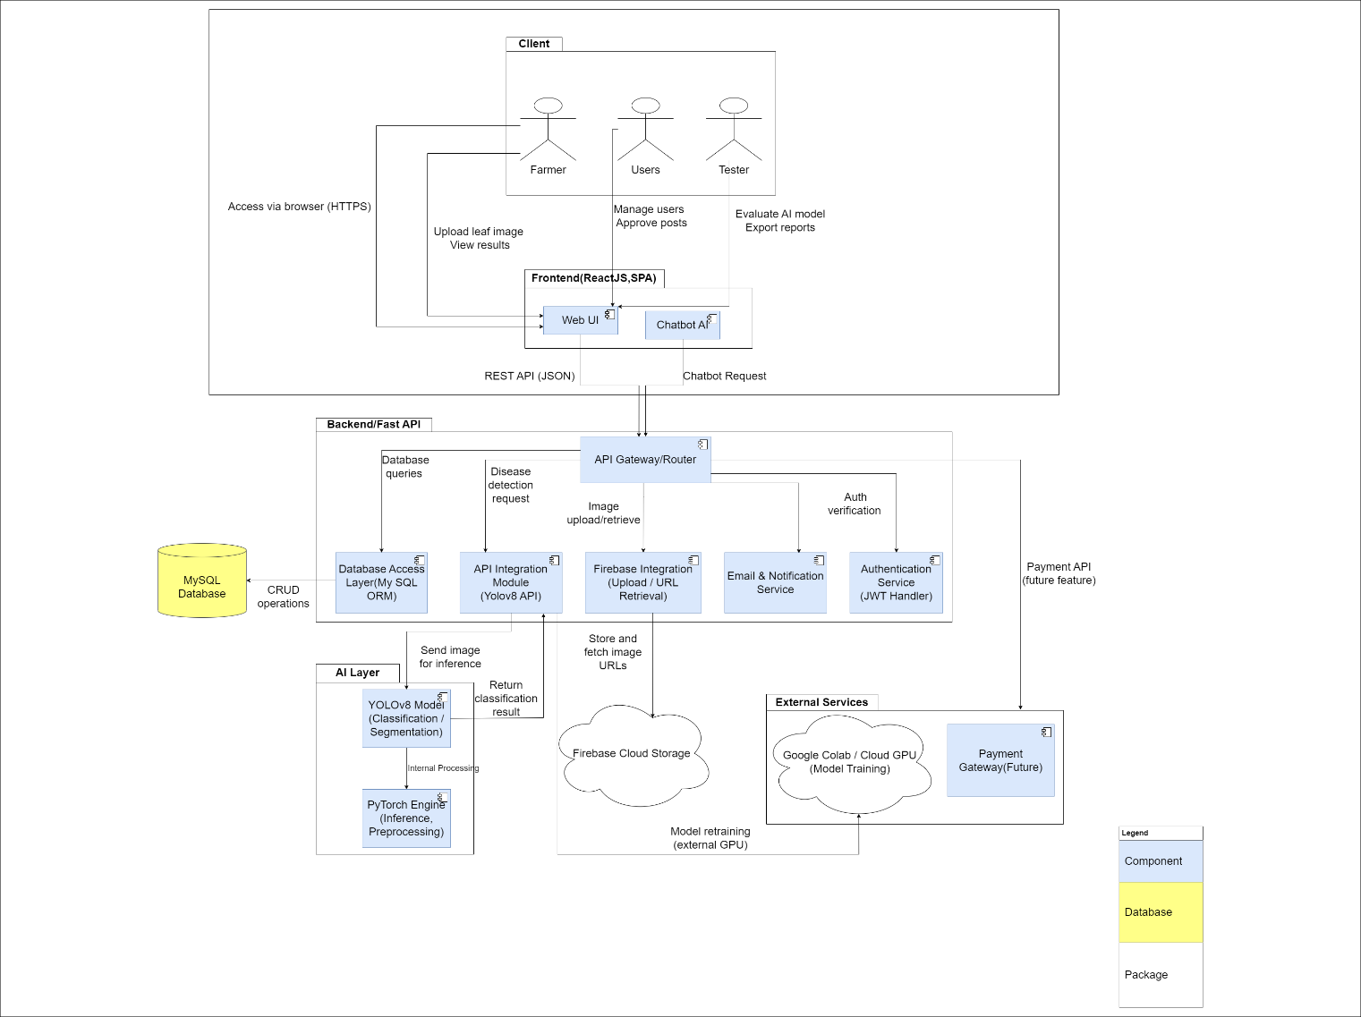
Figure 2. HMS C&C View

Prose: The LeafSense system architecture follows a multi-layered design that separates the application into Client, Frontend, Backend, AI, Data, and External Service layers. Farmers, administrators, and researchers access the system through a ReactJS web interface, where they can upload leaf images, manage content, or evaluate AI performance. The frontend communicates with the backend via RESTful APIs using JSON over HTTPS, ensuring secure and efficient data exchange.
The backend, developed with FastAPI, manages authentication, AI integration, database access, and notification services. The YOLOv8 and PyTorch-based AI layer performs disease classification, while MySQL and Firebase handle structured and image data respectively. External services such as Google Colab support AI model training, with future integration planned for payment and mobile extensions. This modular architecture improves maintainability, scalability, and performance for accurate and accessible coffee disease detection.

Table 25. Component And Connector View
Role | Responsibility
Web Application (ReactJS SPA) | Provides the user interface for Farmers, Administrators, and Researchers. Handles user interactions such as image upload, community activities, and AI result visualization. Communicates securely with the FastAPI backend via RESTful APIs.
API Gateway/  Router(Fast API) | Serves as the single entry point for all client requests. Routes requests to the appropriate backend service (AI, Authentication, Database) and manages authentication, validation, and error handling.
Authentication Service | Manages user registration, login, logout, and token-based (JWT) authentication for all system users. Ensures session security and access control across modules.
AI Integration Module (YOLOv8 API) | Handles requests for coffee leaf disease detection. Sends uploaded images to the trained YOLOv8 model, receives classification results, and returns analysis data to the frontend.
Database Access Layer (MySQL ORM) | Performs CRUD operations for structured data, including user profiles, history of analyses, community posts, and admin logs. Ensures data integrity and consistency.
Firebase Integration Service | Manages uploading, retrieving, and storing coffee leaf images in Firebase Cloud Storage. Returns secure URLs for frontend access..
Email & Notification Service | Sends verification, password reset, and notification emails to users. Supports system alerts and admin communications.
AI Layer (YOLOv8 + PyTorch) | Performs image preprocessing, classification, and segmentation to detect coffee leaf diseases. Provides inference results to the AI Integration Module.
External Service: Google Colab / Cloud GPU | Provides GPU resources for training and retraining AI models. Supports dataset expansion and performance optimization.
External Service: Payment Gateway (Future) | Will enable secure payment transactions for marketplace purchases in future versions.

5.2 Module view

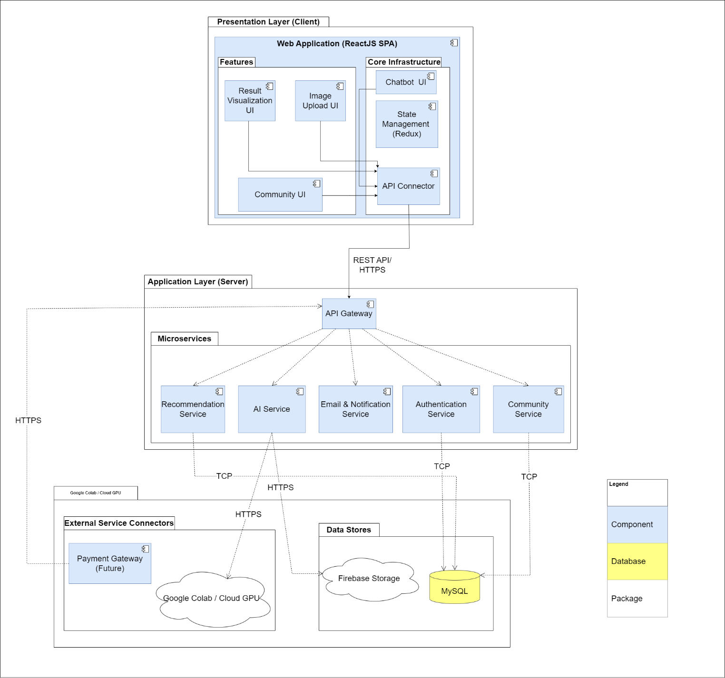
Figure 3. HMS Module View

Prose: This view organizes the system into three distinct layers: Presentation, Application, and Infrastructure. Each layer groups its modules by responsibility, ensuring a clear separation of concerns across the architecture. The Presentation Layer contains the ReactJS UI modules that handle user interactions, while the Application Layer defines backend modules such as authentication, AI services, community management, and recommendations.
The Infrastructure Layer provides foundational support through data storage, external AI training resources, and supporting services such as Firebase and MySQL. This layered structure enhances maintainability and modifiability by allowing updates or replacements in one layer—such as improving the user interface or updating the AI model—without introducing changes to the other layers. It supports clean code organization, easier debugging, and scalable future expansion.

5.3 Allocation View
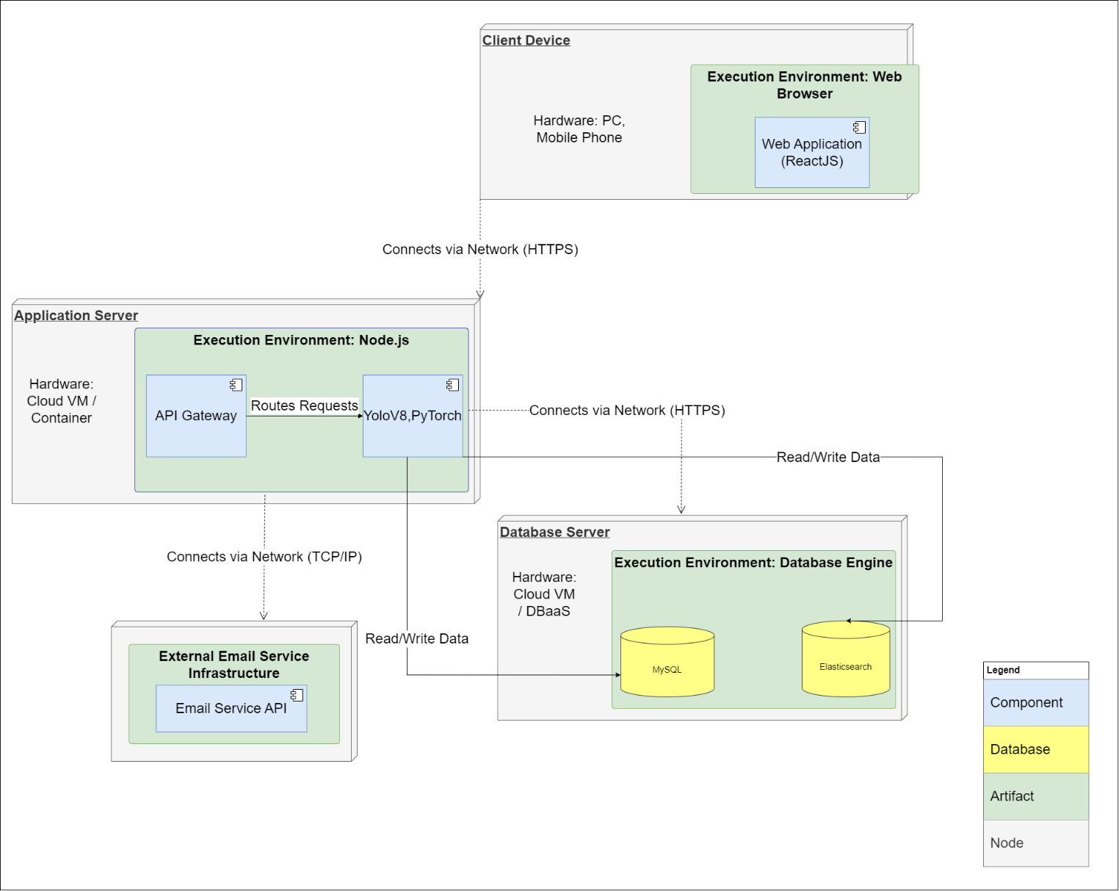
Figure 4. HMS Allocation View

Prose: The Allocation View describes how LeafSense is deployed across its physical and execution environments. The system runs on three main nodes: the Client Device, the Application Server, and the Database Server, with an additional External Email Service.
On the Client Device, the Web Browser executes the ReactJS Web Application, handling all user interactions. It communicates with the backend exclusively through secure HTTPS.
The Application Server, deployed on a cloud VM or container, uses a Node.js execution environment. Inside this environment, the API Gateway routes all incoming requests, while the YOLOv8/PyTorch module performs AI-based image analysis. This server acts as the central processing unit of the system.
The Database Server hosts MySQL and Elasticsearch within a database engine environment. MySQL stores transactional data, while Elasticsearch supports fast searching and indexing. The Application Server interacts with the database through TCP/IP for all read/write operations.
Finally, an External Email Service handles password reset and notification emails. The Application Server communicates with this service externally via TCP/IP.
Overall, the allocation shows a clear distribution: UI on the client, logic and AI on the application server, persistent storage on the database server, and email processing offloaded to an external service.

6.References
[1] Docker: https://www.docker.com
[2] FastAPI: https://fastapi.tiangolo.com
[3] Spring: https://spring.io/

